**LAKIREDDY BALI REDDY COLLEGE OF ENGINEERING (Autonomous)**

L.B. Reddy Nagar, Mylavaram-521 230. Andhra Pradesh, INDIA

Affiliated to JNTUK, Kakinada & Approved by AICTE New Delhi

Accredited by NBA, New Delhi & Certified by ISO 9001:2015, http://www.lbrce.ac.in

**DEPARTMENT OF ELECTRICAL & ELECTRONICS ENGINEERING**

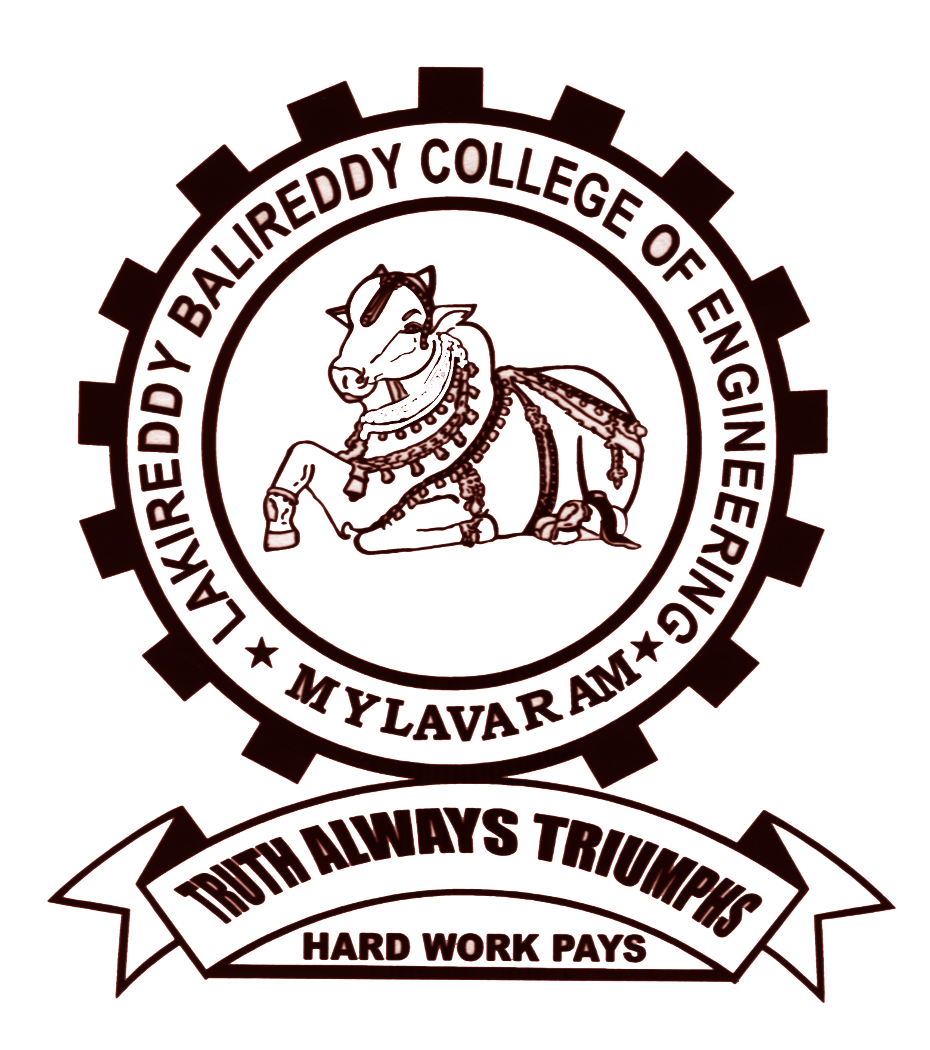

Course: B.Tech Semester: II Code: **20EE01** A.Y: 2023-24

Course Title: Basic Electrical & Electronics Engineering Branch: AI&DS

**UNIT- III: DESCRIPTIVE QUESTIONS**

1. Draw the general layout of the Hydro-electric power plant and discuss each component in detail.
2. Illustrate the working of a Nuclear Power plant with a neat layout diagram.
3. Draw the general layout of the solar power plant and discuss each component in detail.
4. Illustrate the working of a wind Power plant and the various parts in layout with the help of neat sketches.
5. Distinguish between conventional and non-conventional energy sources.
6. Draw a diagram to explain the operation of a fuse and a miniature circuit breaker (MCB).
7. Write the merits and demerits in fuse and miniature circuit breaker (MCB).
8. What are the various kinds of earthing and what does the term "earthing" mean?
9. Explain various personal safety precautions to take when working with electricity?
10. Illustrate the procedure for calculating the electricity bill for domestic consumers.

|  |  |  |  |
| --- | --- | --- | --- |
|  |  |  |  |
| COURSE INSTRUCTOR | COURSE COORDINATOR | MODULE COORDINATOR | HOD |
| Dr.AVGA.Marthanda | Dr.AVGA.Marthanda | DR. G.NAGESWARA RAO | DR. J. S. V. PRASAD |